Jim and Mindy Wiese

Samoa update
December 28, 2019
Just a quick update from SAMOA.
We arrived on the 12th of December and have hit the ground running!
We started with what we thought was intercessory prayer at the Eddie James concert here in Samoa and were asked with some of the team to share a word of exhortation before the concert. All we can say is shift and fire…
Next, due to the measles outbreak the Christmas events were not happening, the island is still in a state of emergency until the 29th of December…but God
We were able to purchase our first batch of shoes and come along side Samoa Victims Support Group as they went to villages to minister to those that have lost children to measles. The count now is 81 lost to measles. We were able to share the love of God in balloons and shoes.
On December 17th we received our 3-year ministerial VISA, we sent our application in November 18th to NY and got here and things happened suddenly!
Mindy preached at Cornerstone a non-denominational church and wow! What a service and move of the Holy Spirit. Many lives encountered God in that service. One little girl was so overcome with the presence of God she just cried and cried and told the Pastor she saw Jesus!
Then we were asked to be part of ministry to those in the hospital. Balloons and shoes and Santa! Open doors and relationships.
We are getting settled into our rental home that we share kitchen and bathroom with the pastors daughter, but have our own private room. We have spent time with our Samoan family here, and are very blessed. We have a few pictures and you can follow us on Facebook #samoamissions
Thank you everyone for the support! Trusting God in our steps that are in front of us because he has gone before us!
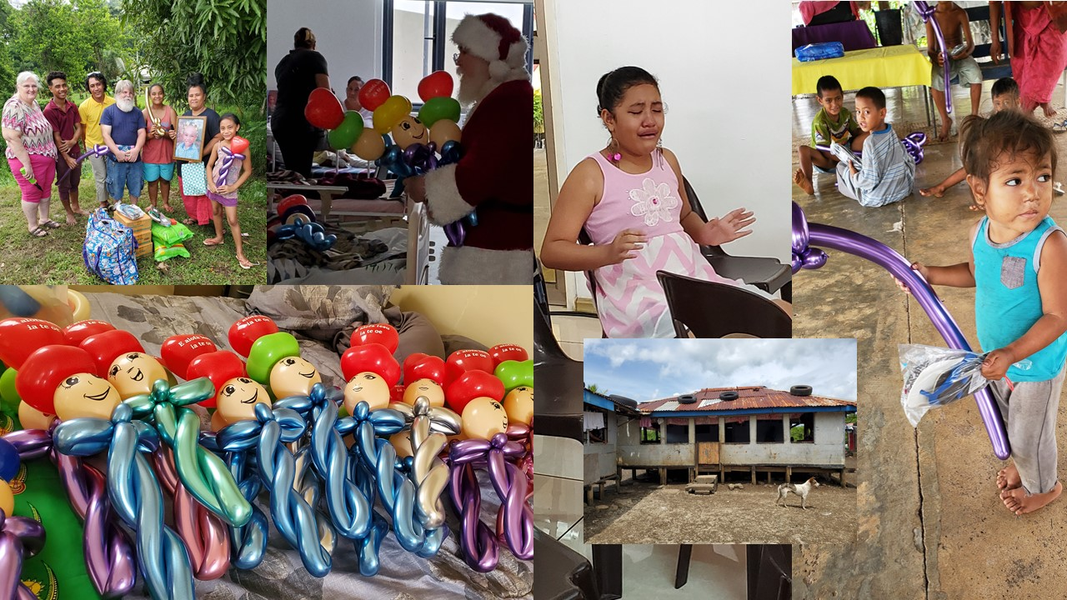
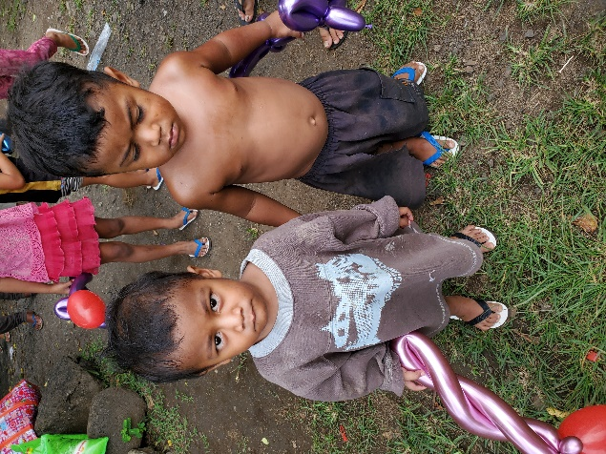
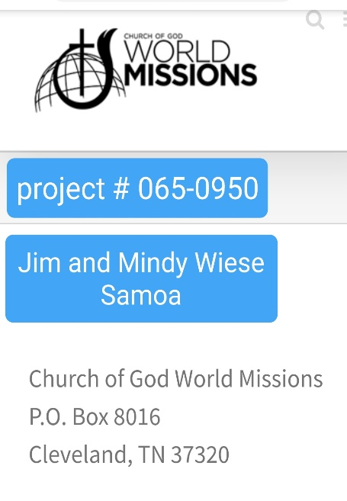 In Christ, Jim and Mindy Wiese

